My analysis is based on the data as generated by the code of the repository at March 27, 2020. While these data are not included in the repository, you can download them as indicated by the code below.

suppressPackageStartupMessages({ library(tidyverse) library(lubridate) library(gghighlight) library(ggrepel)

})

merged <- read_csv("https://joachim-gassen.github.io/data/merged_data_2020-03-27.csv", col_types = cols()) %>%

mutate(date = ymd(date))

read_csv("https://joachim-gassen.github.io/data/npi_acaps_2020-03-27.csv", col_types = cols()) %>%

mutate(npi_date = ymd(date_implemented)) %>% rename(npi_type = category) %>%

mutate(

npi_regional = !is.na(admin_level_name), npi_targeted_pop_group = targeted_pop_group == "Yes", npi_lockdown = str_detect(measure, "General lockdown")

) %>%

select(iso3c, npi_date, npi_type, npi_regional, npi_targeted_pop_group, npi_lockdown) -> npi

As a first question, let’s see how these interventions distribute across calendar time.

ggplot(npi, aes(x = npi_date, fill = npi_type)) + geom_bar(position = "stack") + theme_minimal() +

labs(title = "Implementation of Interventions over Calendar Time", x = "Date",

y = "Number of interventions")

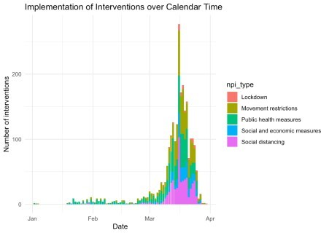

And now: How does this look in event time, meaning normalized to the respective

country’s outbreak timing? I use the day where the number of deaths reaches 10 as event day zero.

merged %>% group_by(iso3c) %>% filter(deaths >= 10) %>%

summarise(edate = min(date)) -> ctry_edate

merged %>%

select(iso3c, country) %>% unique() -> ctry_names

npi %>%

left_join(ctry_edate, by = "iso3c") %>% filter(!is.na(edate)) %>%

mutate(npi_edate = as.numeric(npi_date - edate)) %>% left_join(ctry_names, by = "iso3c") %>%

select(iso3c, country, npi_date, npi_edate, npi_type, npi_lockdown) -> npi_edates

lab_x <- "Days relative to the date where the number of deaths reached 10"

ggplot(npi_edates, aes(x = npi_edate, fill = npi_type)) + geom_bar(position = "stack") + theme_minimal() + labs(title = "Implementation of Interventions over Time",

x = lab_x,

y = "Number of interventions")

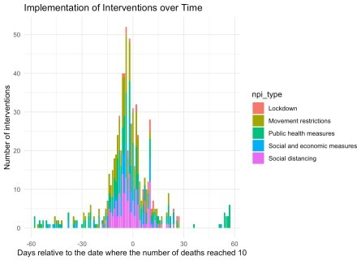

You can clearly see from the histograms that NPIs are clustered both in calendar time and event time. This makes it harder to separate their effects from each other, yielding a lower test power. Based on the graphs, it is hard to tell the different interventions types apart. For this, you can use the next display.

npi_edates %>%

group_by(npi_edate, npi_type) %>% summarise(

npi_count = n()

) %>%

ungroup() %>%

arrange(npi_type, npi_edate) %>% group_by(npi_type) %>%

mutate(npi_count = cumsum(npi_count)) %>%

complete(npi_edate = min(npi_edates$npi_edate):max(npi_edates$npi_edate)) %>% fill(npi_count) %>%

replace_na(list(npi_count = 0)) %>%

ggplot(aes(x = npi_edate, fill = npi_type, y = npi_count)) + theme_minimal() + labs(

x = lab_x,

y = "Percentage share of all interventions at event date", fill = "Intervention type"

) +

geom_area(position = "fill") + scale_y_continuous(labels = scales::percent)

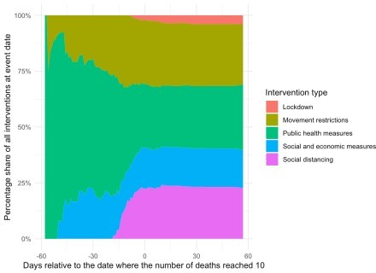

You can see that, in particular, lockdown and social distancing measures are heavily clustered around the two weeks of day zero while socio-economic and public health measures are mostly taken earlier, similar to movement restrictions. This is in inline with governments taking less intrusive measures earlier and hints at the non-randomness of interventions (more on that below).

I will now focus on two types of measures that have been argued to be particular important to flatten the curve: Social distancing and the general lockdown of a country. First let’s see, based on ACAPS data, which countries have more social distancing measures in place and which countries have implemented a lockdown?

merged %>%

inner_join(ctry_edate, by = "iso3c") %>% mutate(edate = as.numeric(date - edate)) %>% group_by(iso3c) %>%

mutate(

lockdown_ctry = max(lockdown) > 0, soc_dist_ctry = max(soc_dist)

) %>%

ungroup() %>%

mutate(soc_dist_ctry = soc_dist_ctry > median(soc_dist_ctry)) -> df

df %>%

select(country, soc_dist_ctry, lockdown_ctry) %>% unique() %>%

arrange(country) -> npi_ctry

ggplot(npi_ctry, aes(x = soc_dist_ctry, y = lockdown_ctry)) + geom_label_repel(aes(label = country)) +

theme_minimal() + labs(

x = "More than median amount of social distancing measures", y = "Lockdown initiated",

caption = paste0(

"Government intervention measures as provided by ",

"Assessment Capacities Project (ACAPS). Data as of March 27, 2020.\n",

"All countries with 10 or more reported deaths are included. “

)

)

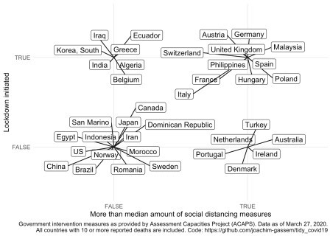

When you look at the data and are somewhat familiar with the activities that several countries have taken, you might be surprised by some of the data points. As an example: No lockdown in China? It seems important to note that coding NPIs is far from trivial and that the ACAPS data provide much more detail on the measures than I use here. You are encouraged and advised to use this richness of the data for your own analyses. In particular, I hope that more regional-level analyses will allow us to assess the effects of NPIs in the future.

As a last step, I would like to provide to visuals to explain why it seems too early (for me) to assess the effectiveness of NPIs at the country level. For that, I use the grouping of countries of the last chart and plot the event daily mean percentage increase in recorded deaths for each group. I require each group to have at least five countries and I calculate the averages by event date as, luckily, there seems to be an overall declining trend of death growth rates over time in the data.

First, let’s compare countries with more social distancing measures with countries that have less social distancing measures in place.

compare_death_growth <- function(df, var) { lab_caption <- paste0(

"Deaths data as provided by Johns Hopkins University Center for Systems Science ",

"and Engineering (JHU CSSE).\nGovernment intervention measures as provided by ",

"Assessment Capacities Project (ACAPS). Data as of March 27, 2020.\n", "At least five daily country-level observations required by group for

)

lab_color <- case_when( var == "soc_dist_ctry" ~

"More than median amount of\nsocical distancing measures", var == "lockdown_ctry" ~ "Lockdown initiated",

TRUE ~ var

)

df %>%

mutate(pct_inc_deaths = deaths/lag(deaths) - 1) %>% filter(edate >= 0) %>%

group_by(edate, !! sym(var)) %>%

filter(n() >= 5) %>% summarise(

mean = mean(pct_inc_deaths),

std_err = sd(pct_inc_deaths)/sqrt(n()), n = n()

) %>%

ggplot(aes(x = edate, y = mean, color = !! sym(var))) + geom_pointrange(

aes(ymin = mean-1.96*std_err, ymax = mean+1.96*std_err), position=position_dodge(0.4)

) + labs(

x = lab_x,

y = "Average daily percentage increase in reported deaths by group", caption = lab_caption,

color = lab_color

) +

theme_minimal() + theme(

legend.position = c(0.75, 0.75), plot.title.position = "plot", plot.caption.position = "plot", plot.caption = element_text(hjust = 0), axis.title.x = element_text(hjust = 1), axis.title.y = element_text(hjust = 1),

) +

scale_y_continuous(labels = scales::percent)

}

compare_death_growth(df, "soc_dist_ctry")

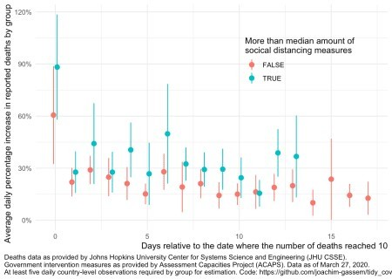

The first thing that you see is that we only have very few data points with overlapping data (13 to be precise). Also, you see the wide and overlapping standard errors. This translates to: At least using such highly aggregated data, it is much too early to assess the impact of government measures on the spread of the virus.

Another thing that you can glance from the data is that, on average, countries with more social distancing measures seem to have higher death growth rates. Why is that? While I want to abstain from interpreting exploratory displays a potential explanation is that countries facing a faster spread of the virus are likely to adopt more rigid measures of social distancing. This non-randomness of governmental interventions is a common issue in regulatory intervention studies and makes it harder to assess the causal effect of regulatory interventions.

Finally, let’s compare this to the graph separating the death growth rates of countries with and without governmental lockdowns:

compare_death_growth(df, "lockdown_ctry")

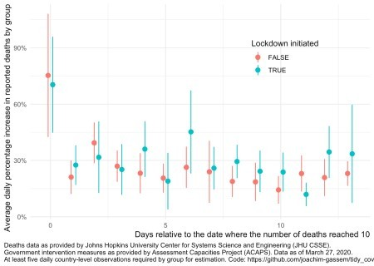

As you can see, the graph looks reasonably similar. We will have to wait until we eventually can learn how the interventions have affected the spread of the virus.